Spring 2024 I Student News

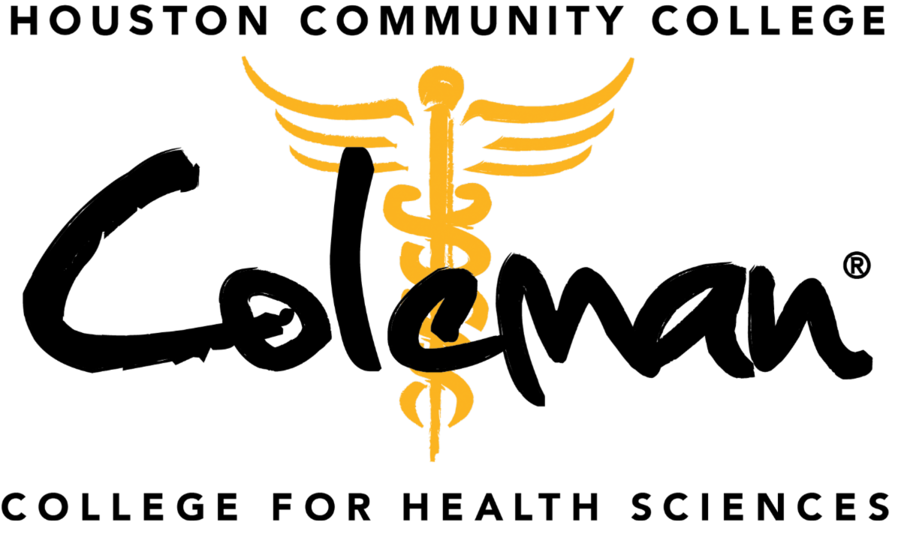

Class of 2024 Pinning Ceremonies

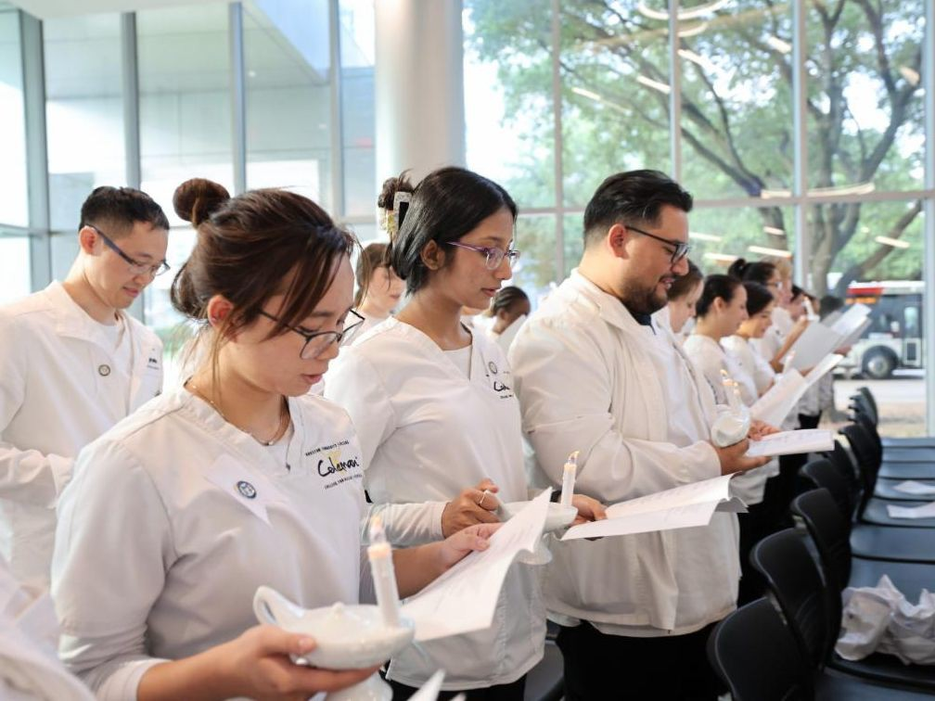
Associate Degree Nursing
Sixty Associate Degree Nursing students received their pin and took their pledge at the April 30 commencement ceremony at Coleman Atrium.

See the photos!

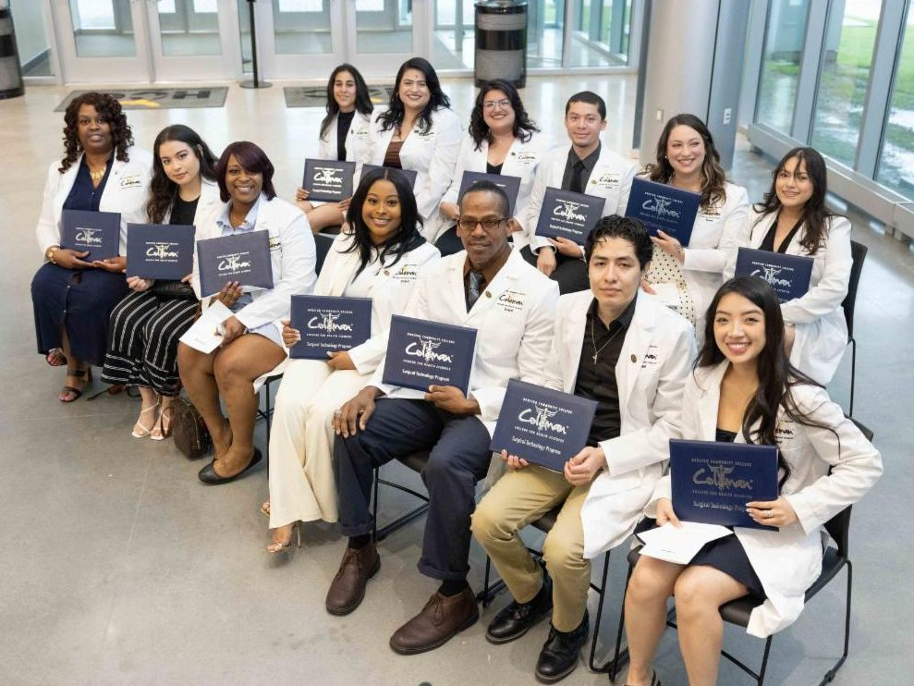
Endoscopy Technician & Surgical Technology
Three Endoscopy Technician and 10 Surgical Technology students received their pin at the May 2 commencement ceremony at Coleman Atrium.

See the photos!

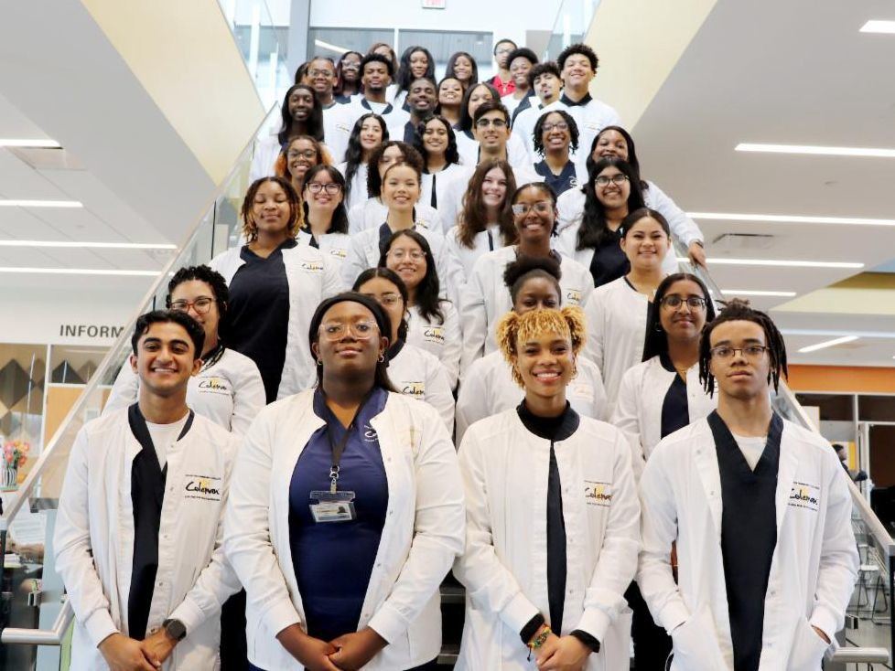
Medical Assistant & Medical Scribe
Twenty-three dual credit Medical Assistant and 21 Medical Scribe students earned their pin at the May 3 commencement ceremony at HCC Missouri City Campus.

See the photos!

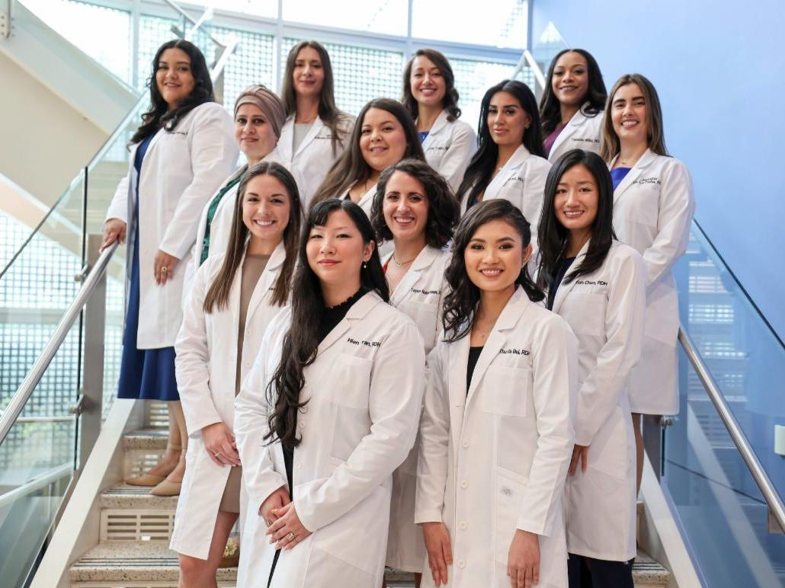
Dental Hygiene
Thirteen Dental Hygiene students received their whitecoat and pin at the May 3 commencement ceremony at Coleman Auditorium.

See the photos!

Occupational Therapy Assistant
Twenty Occupational Therapy Assistant students received their pin at the May 4 commencement ceremony at Coleman Atrium.

See the photos!

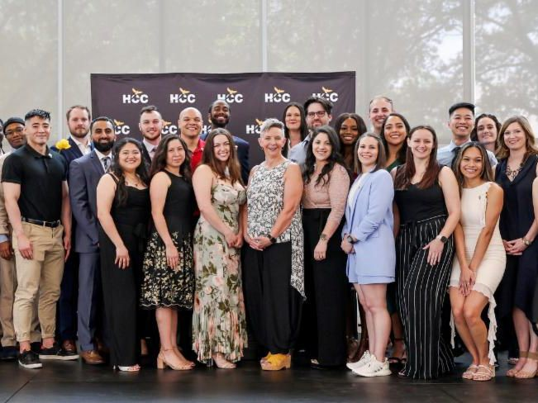
Physical Therapist Assistant
Thirty-two Physical Therapist Assistant students received their pin at the May 4 commencement ceremony at Coleman Atrium.

See the photos!

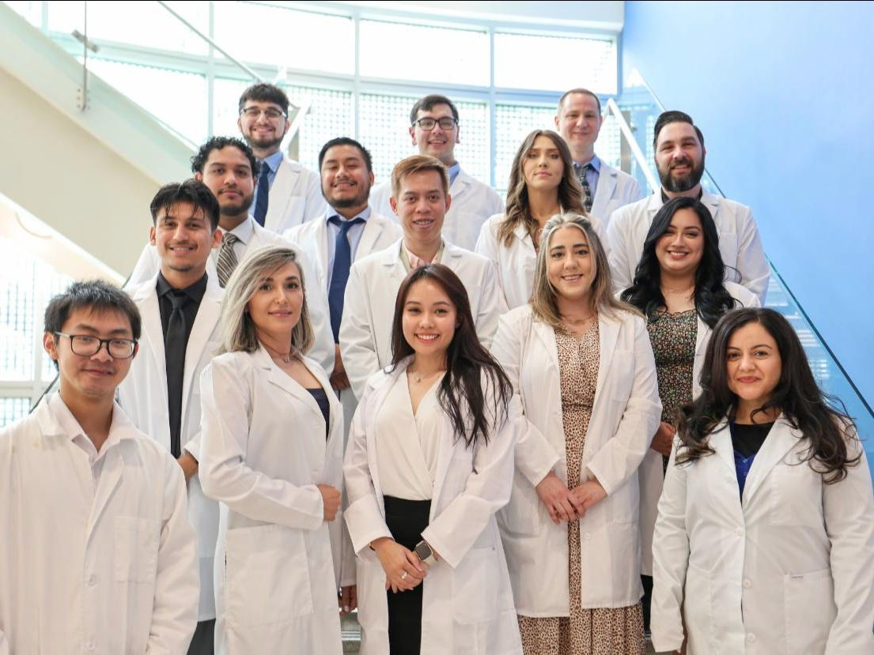
Nuclear Medicine Technology
Twenty-two Nuclear Medicine Technology students received their pin at the May 9 commencement ceremony at Coleman Auditorium.

See the photos!

Pharmacy Technician
Twenty-four Pharmacy Technician students received their pin at the May 9 commencement ceremony at Coleman Tower.

See the photos!

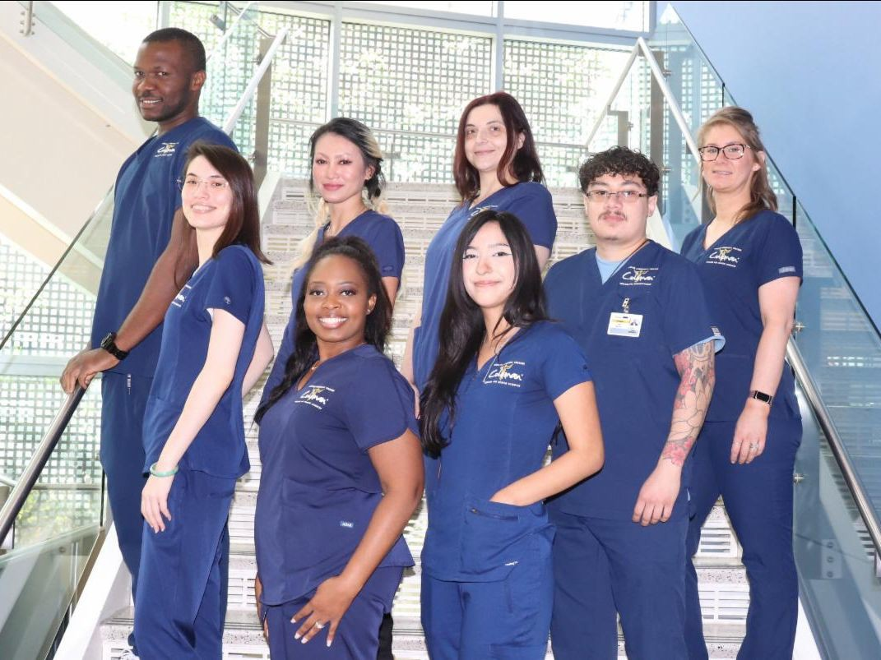
Histologic Technician
Eight Histologic Technician students received their pin at the May 16 commencement ceremony at Coleman Atrium.

See the photos!

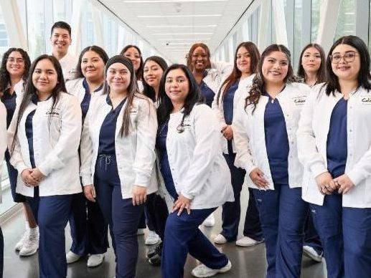
Medical Assistant & Medical Scribe (Full time)
Twenty-four Medical Assistant students and one Medical Scribe student received their pin at the May 16 commencement ceremony at Coleman Atrium.

See the photos!

News Worthy

New Interim President
Meet Dr. Lutricia Harrison and learn how her professional medical background and dedication to student success has equipped her to become Coleman's new interim president!

Read her story!

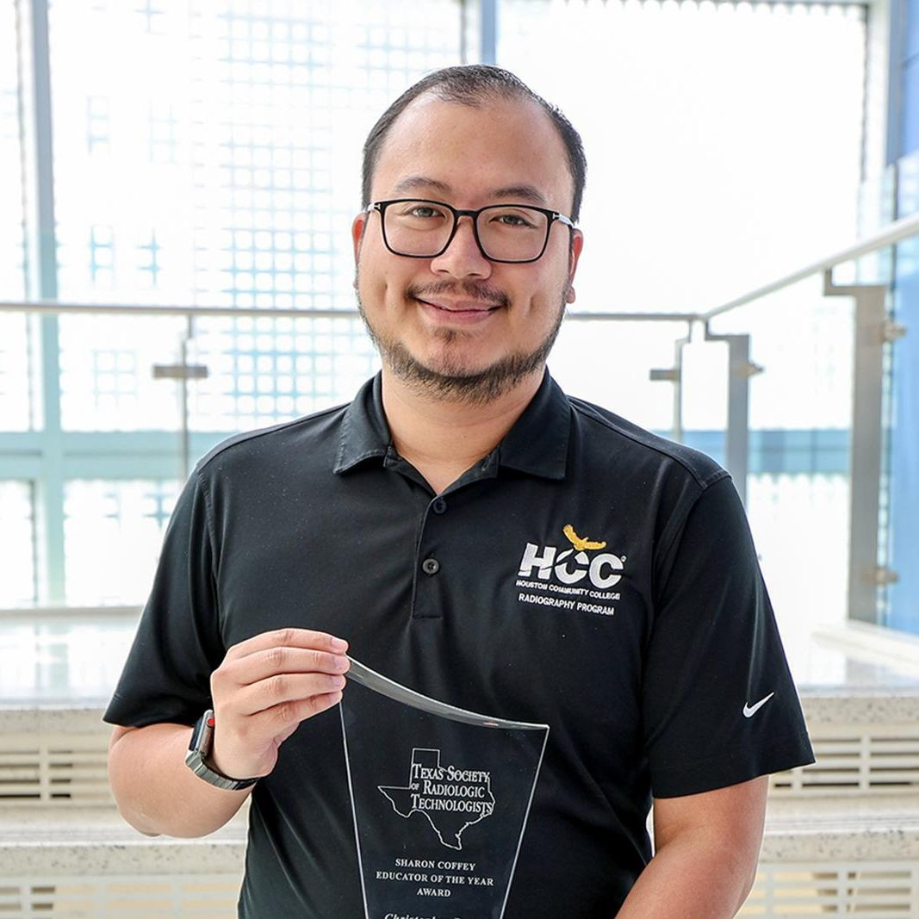
Educator of the Year
Meet Christopher Daza, Radiography & CT program director, and learn why he received the Sharon Coffey Educator of the Year award from the Texas Society of Radiologic Technologists!

Read his story!

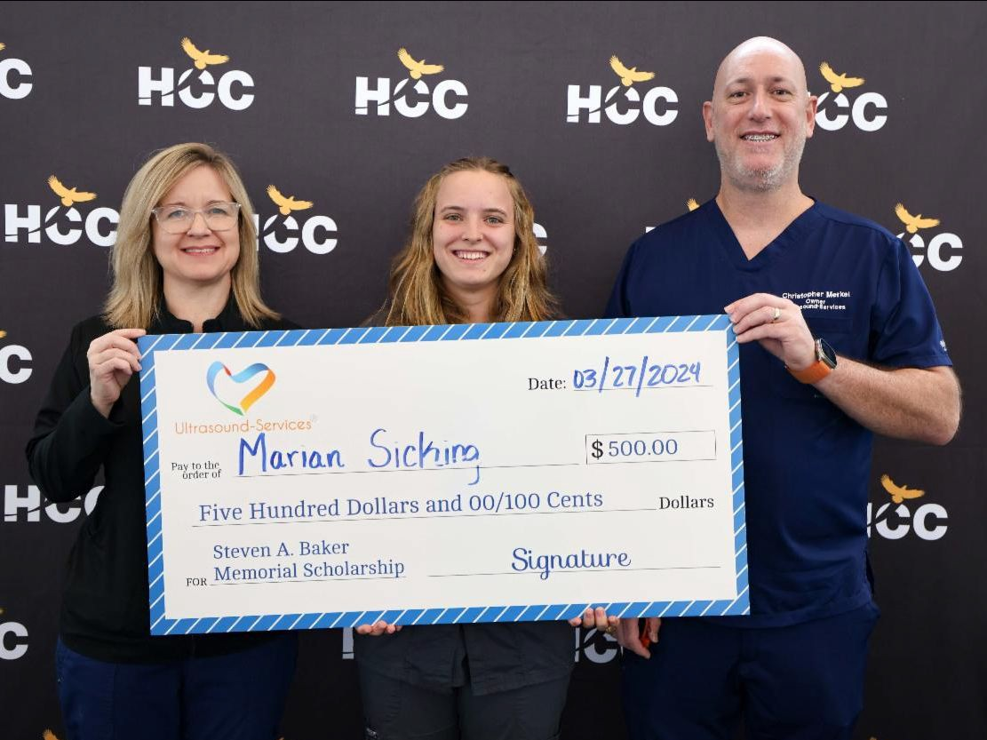
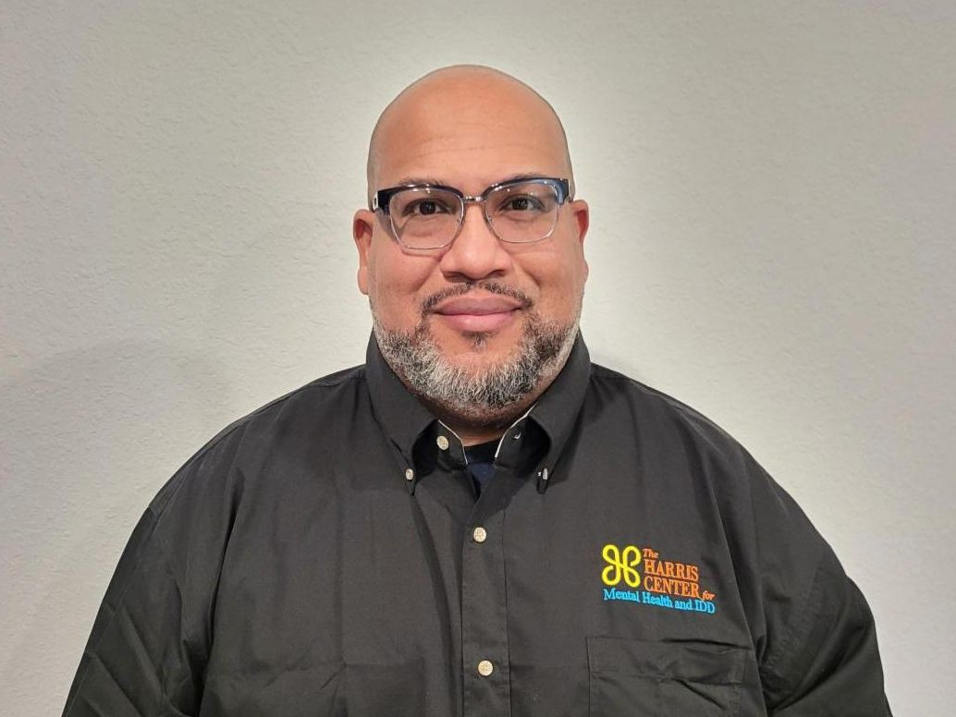
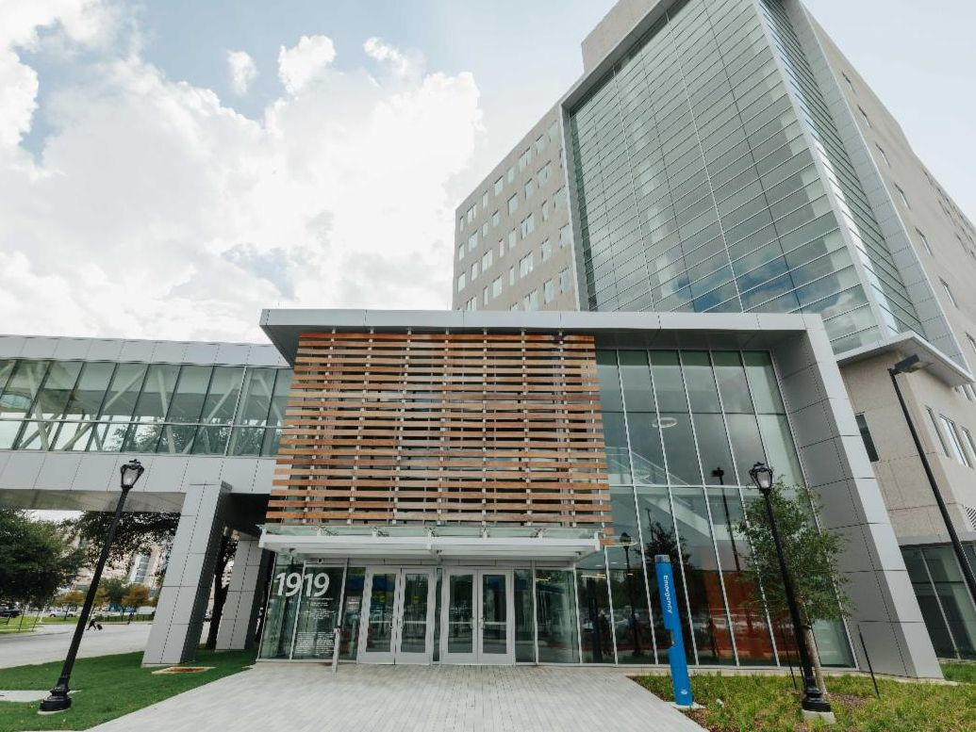

$500 Scholarship Winner

Diagnostic Medical Sonography student Marian Sicking wins the Steven A. Baker Memorial Scholarship! Read her story!
Geoffrey's Story

Learn how Geoffrey Ball, Class of 2013, took a leap of faith into a rewarding new career in behavioral health.
Read his story!
Academic Courses

Healthcare students can now start and finish at the same campus thanks to Coleman's new academic offerings.
Read the story!

Visit Coleman's website to read more stories!

Photo Blast

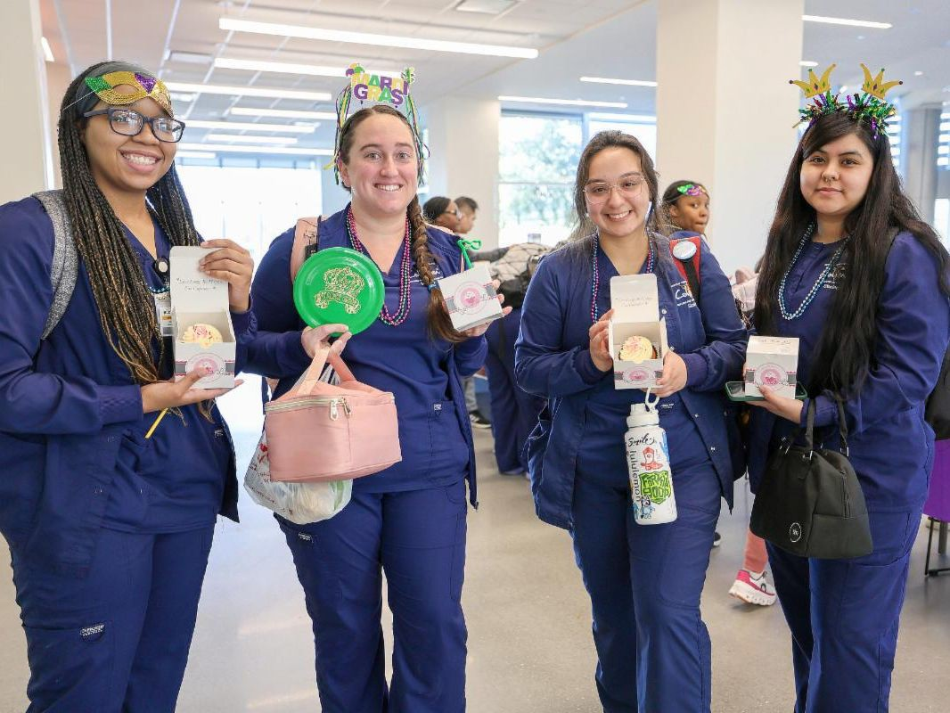
Mardi Gras Celebration
On Feb. 13, Coleman students celebrated Fat Tuesday with beads and cupcakes, and they also decorated lunch bags for Meals on Wheels!

See the photos!

Cinco de Mayo Celebration
On May 2, Coleman students celebrated the Cinco de Mayo (May 5th) holiday with "amigos" and nachos!

See the photos!

Visit Coleman's Flickr to see more albums!

Soaring Students
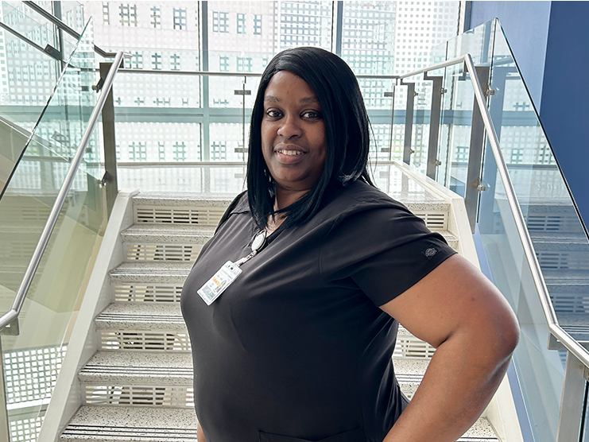

Coleman Champion: Maci Menefee

Read her profile!
Coleman Champion: Tawana Atkins

Read her profile!
Coleman Champion: Angela Tademy

Read her profile!

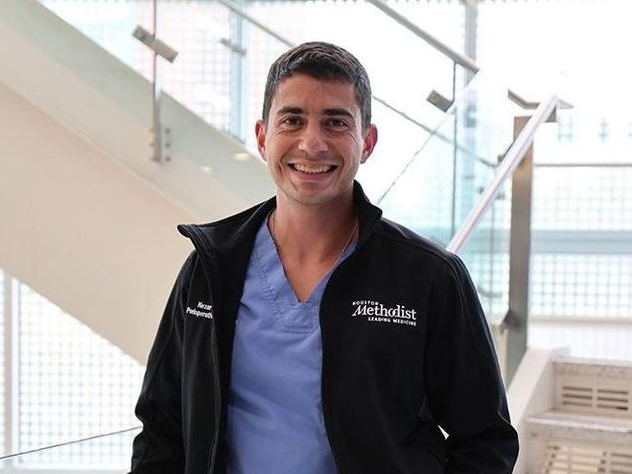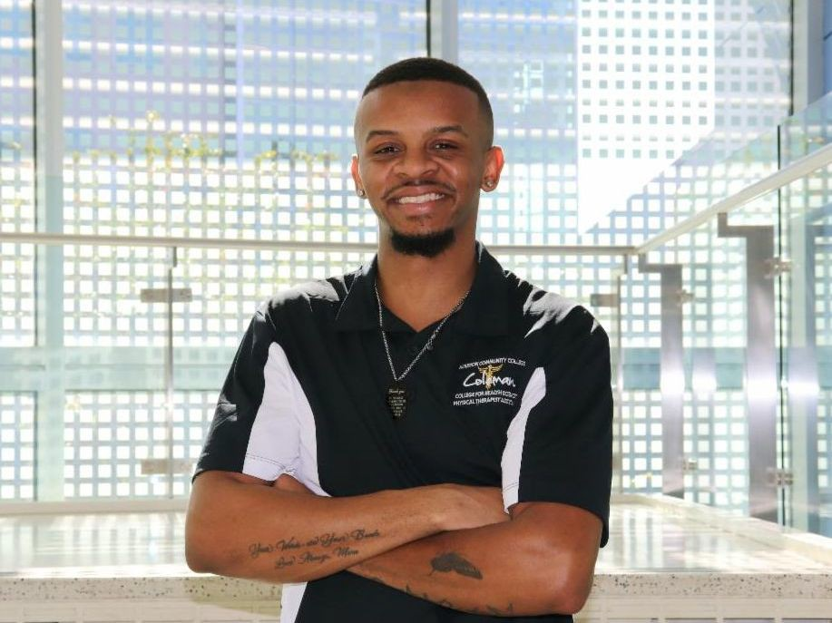

Coleman Colleague: Nezar Nashef

Read his profile!
Coleman Champion: AJ Spruill

Read his profile!
Coleman Colleague: Erin Bass

Read her profile!

Visit Coleman's website to see more students and alumni!

Reel Talk
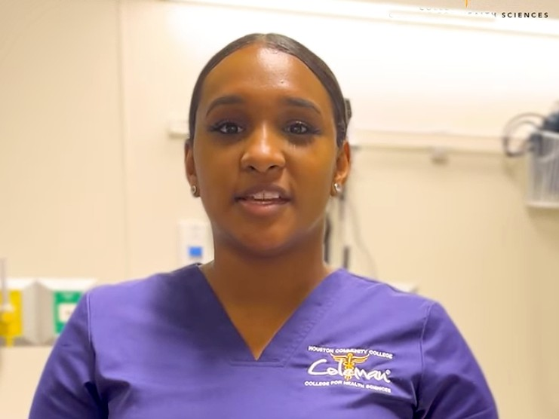
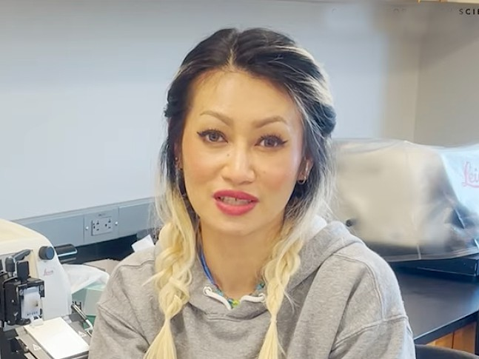

Theodore Davis Health Information

View his testimonial!
Vanessa Perez Nursing - LVN

View her testimonial!
K.L. Cao
Histologic Technician

View her testimonial!

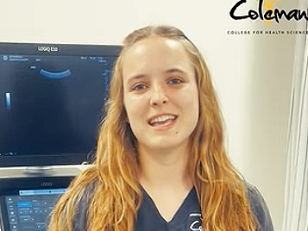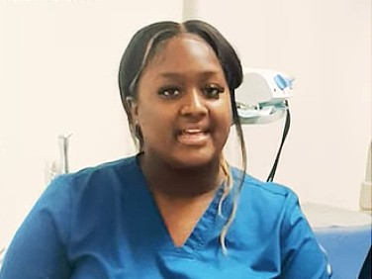

Marian Sicking Sonography

View her testimonial!
Ric McKinney
Healthcare Management

View his testimonial!
Caylin Evans Dental Assisting

View her testimonial!

Visit Coleman's YouTube to see more videos!

Do you have some Eagle news to share?

Email Coleman Communications!

Follow our social media channels for more stories, photos, profiles, and testimonials!

HCC Coleman College | 1900 Pressler St. | Houston, TX 77030 US

Unsubscribe | Update Profile | Constant Contact Data Notice

Constant Contact
@
Try email marketing for free today!

